A Mini project on

Identifying Recyclable Items From Image
submitted in partial fulfillment for award of the degree of Bachelor of Technology in
Information Technology By

G Sai Deepika 23321A1275
B Sai Mounika 23321A1277
P Shriya 23321A1294

Under the Esteemed Guidance of Internal Guide
D Navaneetha
Associate Professor, Information Technology



Bhoj Reddy Engineering College for Women
Department of Information Technology
(Sponsored by Sangam Laxmibai Vidyapeet, Accredited by NAAC with A Grade, Approved by AICTE and Affiliated to JNTUH) Vinaynagar, IS Sadan Crossroads, Saidabad, Hyderabad – 500 059, Telangana. www.brecw.ac.in
Ph: +91 -40-2453 7282; Email: principal@brecw.ac.in

AY 2025–26



Bhoj Reddy Engineering College for Women
Department of Information Technology
(Sponsored by Sangam Laxmibai Vidyapeet, Accredited by NAAC with A Grade, Approved by AICTE and Affiliated to JNTUH)
Recognized by UGC under section 2(f) of the UGC Act,1956
Vinaynagar, IS Sadan Crossroads, Saidabad, Hyderabad – 500 059, Telangana. www.brecw.ac.in

Ref No: BRECW/IT Dept/Project 2025-26/MP-B-02 Date: 30-03-2026

CERTIFICATE

This is to certify that the Major Project entitled “Identifying Recyclable Items from Image” is a bonafide work carried out by

G Sai Deepika 23321A1275
B Sai Mounika 23321A1277
P Shriya 23321A1294

In partial fulfillment for award of the degree of Bachelor of Technology in Department of Information Technology from Bhoj Reddy Engineering College for Women, Hyderabad affiliated to Jawaharlal Nehru Technological University Hyderabad (JNTUH).

D Navaneetha Dr M Sandhya Rani External Examiner Internal Guide Head of the Department

Sangam Laxmibai Vidyapeet is an educational society for promotion of education among girls and women.
It is established in 1952 and registered under the Telangana Societies Registration Act.

ACKNOWLEDGEMENT
It is our pleasure to express our whole hearted thanks to our internal guide D Navaneetha, Associate Professor, Department of Information Technology , for her extreme guidance and support in completing this project successfully.
We are thankful to our project coordinator D Navaneetha, Associate Professor, Department of Information Technology, for her dynamic valuable guidance and constant management.
We express thanks and gratitude to Dr M Sandhya Rani, Associate Professor & Head of the Department, Information Technology, for her encouragement and guidance in carrying out the major project presentation.
We would also like to thank Dr G Shyama Chandra Prasad, Professor & Principal of Bhoj Reddy Engineering College for Women for encouragement in carrying out our mini project successfully. We are also thankful to the staff members of Information Technology department, my friends and to our parents who helped us in completing this project successfully.

By

G Sai Deepika (23321A1275)
B Sai Mounika (23321A1277)
P Shriya (23321A1294)

Index

Contents | Page No
List of Figures/Screenshots | i
Abstract | ii
1. Introduction | 1-3
1.1 Purpose of the Project | 1
1.2 Existing System | 2
1.3 Proposed System | 2
1.4 Advantages of Proposed System | 3
2. Related Work | 4
2.1 Survey | 4
3. Requirement Analysis | 5-8
3.1 Functional Requirements | 5
3.2 Non Functional Requirements | 5-6
3.3 Computational Requirements | 7
3.3.1 Software Requirements | 7
3.3.2 Hardware Requirements  3.3.3 About Dataset | 7-8
4. Design | 8-14
4.1 Architecture | 8-12
4.1.1 System Architecture | 8-9
4.1.2 Technical Architecture | 10-13
4.2 Modules | 14
5. Implementation | 15-24
5.1 Pseudo Code | 15-24

6. Screenshots | 25-28
7. Test Cases | 29
8. Conclusion | 30
9. Future Scope | 31
- References | 32

List of Figures

S. No | Figure Name | Fig. No | Page No
1 | System Architecture | 4.1.1.1 | 10
2 | Technical Architecture | 4.1.2.1 | 13

Abstract
With the rapid increase in waste production, efficient waste management has become a critical environmental challenge. This project proposes an intelligent system that automatically identifies recyclable items from images using machine learning and computer vision techniques.The system utilizes image classification models, particularly Convolutional Neural Networks (CNNs), to analyze images and categorize objects into recyclable and non-recyclable classes such as plastic, paper, metal, and glass. A labeled dataset of waste images is used to train the model, enabling it to learn distinguishing features of different materials. Data preprocessing techniques such as resizing, normalization, and augmentation are applied to improve model performance and generalization.
The developed model can be integrated into real-time applications such as smart waste bins or mobile applications, assisting users in proper waste segregation. This not only reduces human effort but also improves recycling efficiency and minimizes environmental pollution.The project demonstrates the practical application of machine learning in sustainability and smart city initiatives. Future enhancements may include expanding classification categories, improving accuracy with advanced deep learning models, and deploying the system on edge devices for real-time usage.
Keywords: Machine Learning, Computer Vision, Image Classification, Waste Segregation, Recycling Detection, Convolutional Neural Networks (CNN), Sustainable Technology, Smart Waste Management
.

ii

1.Introduction

1.Introduction
Identifying Recyclable Items from Image Introduction
The main goal of our project, Identifying Recyclable Items from Images, is to develop an automated system that helps in identifying recyclable waste efficiently. With the increasing amount of waste, proper segregation has become essential, but manual sorting is often inaccurate and time consuming.
This project uses Machine Learning and Computer Vision to classify waste items such as plastic, paper, glass, and metal from images. A deep learning model is trained on labeled datasets to recognize patterns and accurately categorize materials. The system can be used as a mobile or web application where users upload images and receive instant results. It aims to simplify recycling, reduce human effort, and promote environmental sustainability.

1.1 Purpose of the Project:

The purpose of this project, Identifying Recyclable Items from Image, is to develop an intelligent system that can automatically detect and classify recyclable waste materials using image processing techniques. Improper waste segregation is a major issue that reduces recycling efficiency and increases environmental pollution.
By utilizing Machine Learning and Computer Vision, the project aims to minimize human effort and errors in identifying recyclable items such as plastic, paper, glass, and metal . The system is designed to provide quick and accurate results, making waste management more efficient.
Ultimately, the project promotes environmental sustainability by encouraging proper recycling practies and enabling smarter waste disposal solutions for individuals and organizations.

Department of IT, BRECW Page 1

Identifying Recyclable Items from Image Introduction
1.2 Existing System:
In the current scenario, waste segregation is primarily carried out manually by individuals or sanitation workers. This traditional method depends heavily on human knowledge and awareness to distinguish between recyclable and non-recyclable materials, which often leads to mistakes and improper disposal. As a result, many recyclable items end up in landfills, reducing the overall efficiency of recycling processes. Although some advanced recycling plants use mechanical sorting techniques, these systems are costly and not accessible for everyday use or small-scale applications. Moreover, there are very few user-friendly tools available that help people identify recyclable items accurately in their daily lives. Most existing solutions lack real-time assistance and are not widely adopted. Furthermore, current systems do not effectively utilize modern technologies like Machine Learning and Computer Vision, which could significantly improve accuracy and automation. This limitation highlights the need for a smarter, more efficient system that can assist users in proper waste segregation and promote better recycling practices.

1.3 Proposed System:
The proposed system introduces an AI-based recyclable item identification model that utilizes Convolutional Neural Networks (CNN) along with image processing techniques to automate waste classification. The system is designed to automatically detect waste items from images and classify them into recyclable and non-recyclable categories with high accuracy. It supports multiple material types such as plastic, paper, glass, and metal, making it versatile for real-world applications.
By leveraging Machine Learning and Computer Vision, the model provides fast and reliable predictions using trained deep learning algorithms. The system is scalable and can be integrated into various platforms, including smart waste bins, recycling plants, and mobile applications. Overall, it enhances efficiency, reduces manual effort, and promotes eco-friendly waste disposal practices.

Department of IT, BRECW Page 2

Identifying Recyclable Items from Image Introduction
1.4 Advantages of Proposed System:
- Automated waste identification and classification.
- High accuracy using deep learning algorithms.
- Reduces human effort and sorting time.
- Supports real-time smart recycling applications.
- Environmentally beneficial and sustainable.
- Easy integration with IoT-based smart bins and mobile apps.

Department of IT, BRECW Page 3

Department of IT,BRECW Page 4

2. Related Work

Identifying Recyclable Items from Image Related Work WWork
2. Related Work

2.1 Survey:
To understand the real-world need for an automated recyclable item identification system, a structured survey was conducted among students, households, and general users who regularly deal with waste disposal. The respondents mainly included college students, working professionals, and residents from urban areas, as they represent a significant portion of daily waste generators. The survey revealed that approximately 72% of participants were unsure about correctly identifying recyclable and non-recyclable waste items. The primary reasons included lack of awareness, confusion between material types (such as plastic and biodegradable waste), and absence of proper guidance tools. When asked whether they would use an application that could automatically identify recyclable items from images, around 70% responded “yes,” while 20% expressed possible interest.This indicates a strong need for an intelligent and user-friendly solution for waste classification. Another key finding was that nearly 80% of respondents believed that improper segregation is one of the major reasons for inefficient recycling processes. Additionally, 76% of users expressed interest in using a mobile-based system that could provide instant results by simply capturing or uploading an image of waste.Participants also suggested features they would prefer in such a system, including accurate classification, real-time detection, support for multiple waste categories (plastic, paper, glass, metal), and a simple interface. These requirements strongly align with the proposed system, which leverages Machine Learning and Computer Vision for automated waste identification.Overall, the survey highlights a clear gap in existing waste management practices and confirms the demand for a smart, accessible, and efficient recyclable item identification system that can assist users in proper waste segregation and promote environmental sustainability.

Department of IT, BRECW Page 4

3. Requirement Analysis

- Requirement Analysis
Identifying Recyclable Items from Image Requirement Analysis

3.1.Functional Requirements:
- The system should allow users to upload or capture images of waste items in formats like JPG or PNG.
- The system should preprocess the input image (resizing, normalization, enhancement) for better analysis.
- The system should classify the item into recyclable and non-recyclable categories.
- The system should further identify material types such as plastic, paper, glass, and metal.
- The system should use Machine Learning and Computer Vision techniques for accurate classification.
- The system should include a simple and user-friendly interface.
- The system may store prediction data for future improvements.
  - Non-Functional Requirements:
- Performance: Fast image processing within seconds
- Accuracy: High classification accuracy (85–90%)
- Reliability: Stable and consistent system behavior
- Usability: Simple and user-friendly interface
- Scalability: Supports growing users and data
- Security: Ensures data and image protection

Department of IT, BRECW Page 5

3.2.1. Performance: The system must operate with high responsiveness, ensuring that image upload, processing, and classification are completed within a few seconds. The prediction results should be displayed in real time without noticeable delay. The model inference and UI transitions must be smooth and efficient even when handling multiple requests.
Identifying Recyclable Items from Image Requirement Analysis
3.2.2. Security User data, including uploaded images and system interactions, must be securely handled. The system should implement secure authentication (if applicable) and ensure safe data transmission using encrypted protocols such as HTTPS. Unauthorized access must be prevented, and user privacy must be maintained without storing sensitive data unnecessarily.
3.2.3. Scalability: The system must support an increasing number of users and image uploads without performance degradation. The architecture should be flexible and scalable, allowing integration with cloud services or upgraded models. The database and backend services must handle growth efficiently.
3.2.4. Usability: The application should be simple and intuitive, allowing users to upload images and receive results with minimal steps. The interface should be clear, responsive, and accessible to users with basic technical knowledge. Output should be easy to understand (e.g., recyclable or not recyclable).
3.2.5. Reliability: The system must consistently provide accurate and stable results under normal and heavy usage conditions. It should handle invalid or unclear images gracefully and avoid crashes or failures. Errors must be communicated clearly to the user with appropriate messages.
3.2.6. Availability: The application must be available at all times (24/7) for users to upload and analyze images. Downtime should be minimal and scheduled during low usage periods. Core functionalities like image upload and prediction must remain accessible even during high traffic.
Department of IT, BRECW Page 6

Identifying Recyclable Items from Image Requirement Analysis
3.3 Computational Resource
3.3.1 Software Requirements:
  - Operating System : Windows / Linux / macOS
  - Programming Language : Python
  - Libraries : TensorFlow, Keras, OpenCV, NumPy, Pandas, Matplotlib
  - Development Tools : Jupyter Notebook / VS Code
  - Dataset : TrashNet or other recycling image datasets

    - Hardware Requirements:
  - Processor : Intel i5 or above
  - RAM : Minimum 8 GB (16 GB recommended)
  - Hard Disk : 20 GB or more
  - Camera : For real-time image capture (optional)

3.3.3 Dataset Description

The dataset used for training the model is the Garbage Classification Dataset obtained from Kaggle.
This dataset contains labeled images of various types of waste materials, which are used to train
the Convolutional Neural Network (CNN) model for classification.

The dataset includes the following categories:
- Plastic
- Paper
- Glass
- Metal
- Cardboard
Department of IT, BRECW Page 7

- Biological waste
Identifying Recyclable Items from Image Requirement Analysis
- Clothes
- Shoes
- Trash
- Battery

Each image is labeled according to its category, enabling the model to learn and distinguish between recyclable and non-recyclable items effectively.

Dataset Details:
- Source: Kaggle (Garbage Classification Dataset)
- Image format: JPG/PNG
- Image size: Resized to 224 × 224 pixels
- Total classes: 10 categories
- Dataset split:
• Training data: 80%
• Validation data: 20%

Preprocessing Techniques:
- Image normalization (scaling pixel values between 0 and 1)
- Data augmentation (rotation, zoom, horizontal flipping)
- Resizing images for uniform input

This dataset helps the CNN model to extract meaningful features and improve classification accuracy for real-world waste identification.

Department of IT, BRECW Page 8

Department of IT, BRECW Page 10

4. Design

Identifying Recyclable Items from Image Design
4. Design

4.1 Architecture:
4.1.1 System Architecture:
It describes the structure and behavior of technology infrastructure of an enterprise, solution or system. In other words, System architecture can be described as the flow of application which is represented below in the pictorial form. He purpose of system architecture activities is to define a comprehensive solution based on principles, concepts, and properties logically related to and consistent with each other. The solution architecture has features, properties, and characteristics which satisfy, as far as possible, the problem or opportunity expressed by a set of system requirements (traceable to mission/business and stake holders requirements).
System architecture is abstract, conceptualization-oriented, global, and focused to achieve the mission and life cycle concepts of the system. It also focuses on high-level structure in systems and system elements. It addresses the architectural principles, concepts, properties, and characteristics of the system-of-interest. It may also applied to more than one system, in some cases forming the common structure, pattern, and set of requirements for classes or families of similar or related systems.
The SEBoK considers systems engineering to cover all aspects of the creation of a system, including system architecture.
The majority of interpretations of system architecture are based on the fairly intangible notion of structure (i.e relationships between elements). Some authors limit the types of structure considered to be architectural: for example, restricting themselves to functional and physical structure. Recent practice has extended consideration to include behavioral, temporal and other dimensions of structure.
ISO/IEC/IEEE 42010 Systems and Software Engineering Architecture Description (ISO 2011) provides a useful description of the architecture considering the stakeholder concerns,architecture viewpoints, architecture views, architecture models, architecture descriptions, and architecting throughout the life cycle.
Department of IT, BRECW Page 9

Identifying Recyclable Items from Image Design
A discussion of the features of systems architectures can be found in(Maier and Rechtin 2009). An attempt to develop and apply a systematic approach to characterizing architecture belief systems in systems engineering has been described by the INCOSE UK Architecture Working Group (Wilkinson et al.2010, Wilkinson 2010).
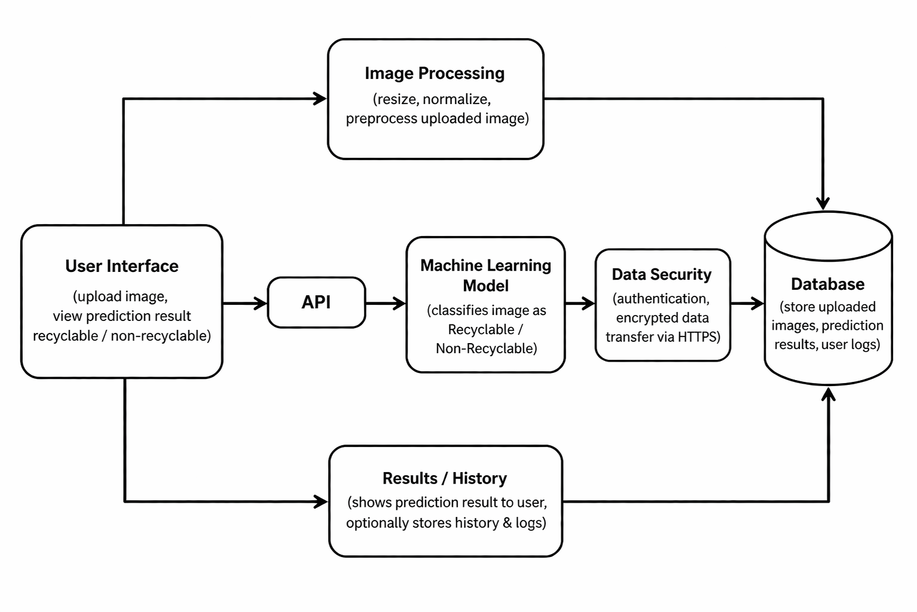
Fig. 4.1.1.1 System Architecture

Department of IT, BRECW Page 10

Identifying Recyclable Items from Image Design
4.1.2 Technical Architecture:
Technical Architecture refers to the structural process of designing and building system’s

architecture with focus on the users and sponsors view of the environment. Technology architecture associates application components from application architecture with technology components representing software and hardware components. Its components are generally acquired in the market place and can be assembled and configured to constitute the enterprise’s technological infrastructure. A technical architecture diagram provide a bird’s eye view of the infrastructure of our project. The diagram illustrates how components in a system interact with one another in the large scale of things. Technical Architecture (TA) is a form of IT architecture that ids used to design computer system. It involves the development of a technical blueprint with regard to the arrangement, interaction, and interdependence of all elements so that system-relevant requirements are met.

Department of IT, BRECW Page 11
Identifying Recyclable Items from Image Design
Throughout the past decade, architecture has become a broadly used term in the context of information technology. This doesn’t come as a surprise considering how most companies had to redesign their IT landscape to adopt digital trends like cloud computing software as service (SaaS). This digital transition required not only skilled developing teams but first and foremost IT architects. In their roles as IT strategists and planners, they map out a target architecture and make sure that all IT decisions align with business goals and requirements. But IT architecture encompasses a variety o different roles and disciplines that are sometimes difficult to tell apart. This is largely due to highly dynamic nature of IT, its widespread adoption throughout all industries and business that have developed their own practices. In general, there’s differentiation between enterprise architecture, solution architecture and technology architecture. In order to understand what technology architecture means, it’s helpful to examine the term
architecture on its own.
At its core, the term architecture describes the formation of a structure by strategically assembling single components. In this process of assembling, the architect has to adhere to certain rules or requirements like legal constraints, financial constraints or scientific laws. In the world technology architecture design, the focus lies on technology limitations, meaning that a technology architect makes sure that a new application is compatible with the existing technology at a company by specifying things like the communications network or hardware that it uses.
Department of IT, BRECW Page 12

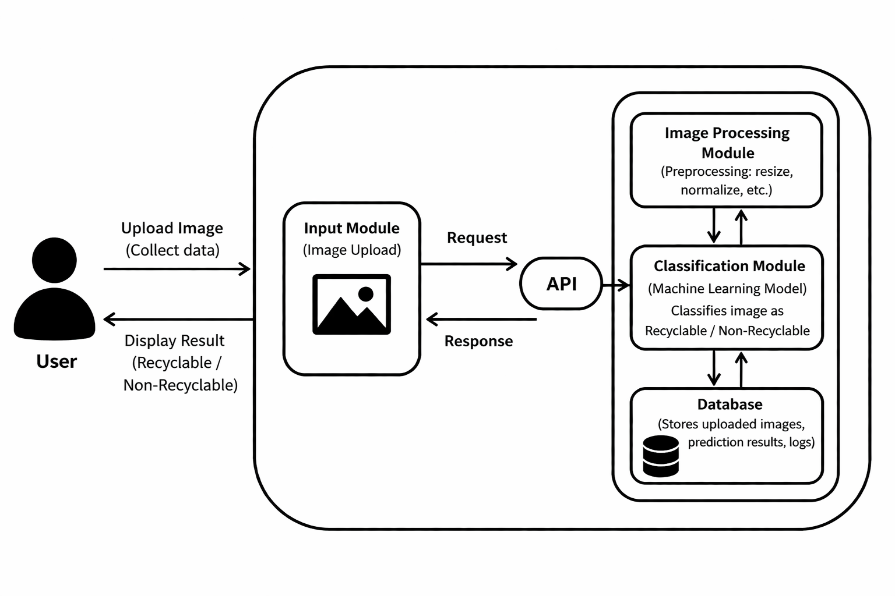
Identifying Recyclable Items from Image Design
Fig. 4.1.2.1 Technical Architecture
Department of IT, BRECW Page 13

Identifying Recyclable Items from Image Design
4.3 Modules
A module is a part of a program. Programs are composed of one or more independently developed modules. A module description provides detailed information about a module and its supported components. The included description is available directly by making environment checks for supported components. The modules are: The modules are
- Image Upload & Input Management:
Handles image acquisition from users through file upload or camera input. Ensures supported formats (JPG, PNG) and performs basic validation such as file size and image quality checks before processing.
- Image Preprocessing Module:
On boarding and profile management for PR professionals, offering personalized styling advice, virtual consultations, and fashion rentals/customization based on event preferences.
- ML Model Prediction Module:
Core module responsible for analyzing the image using a trained machine learning/deep learning model (e.g., CNN). It classifies the object and determines whether it is recyclable or non-recyclable.
- Classification & Result Management:
Interprets model output and categorizes items into predefined classes (e.g., plastic, paper, metal,
organic waste). Generates final results with labels and confidence scores.
- Data Storage & History Management:
Allows users to give feedback on prediction accuracy. This data can be used to retrain and
improve the machine learning model over time.
Department of IT, BRECW Page 14

Department of IT, BRECW Page 20

5. Implementation

5.1 Pseudo code
Identifying Recyclable Items from Image Implementation
Algorithm: Convolutional Neural Network (CNN)

Input: Image dataset (X), Labels (Y)
Output: Trained CNN model

Step 1: Initialize CNN model
- Define convolution layers, pooling layers, fully connected layers
- Initialize weights and biases

Step 2: Preprocess input images
- Resize images to fixed size (224×224)
- Normalize pixel values (0–1)
- Apply data augmentation (rotation, flipping)

Step 3: Forward propagation
- Apply convolution operation to extract features
- Apply ReLU activation function
- Apply pooling to reduce dimensions
- Repeat for multiple layers
- Flatten feature maps
- Pass through fully connected layer
- Apply Softmax for classification

Step 4: Compute loss
- Use categorical cross-entropy loss

Step 5: Backpropagation
- Calculate gradients
- Update weights using optimizer (Adam)

Step 6: Repeat for multiple epochs
- Until model achieves good accuracy

Step 7: Save trained model

Step 8: Use model for prediction

Department of IT, BRECW Page 15

Identifying Recyclable Items from Image Implementation
login.html:
<!DOCTYPE html>
<html>
<head>
<script src="https://cdn.tailwindcss.com"></script>
</head>
<body class="bg-gradient-to-br from-purple-500 via-pink-500 to-red-500 min-h-screen flex justify-center items-center text-white">

<div class="bg-white/10 p-8 rounded-2xl w-full max-w-md text-center shadow-2xl">
<h1 class="text-3xl font-bold mb-6">♻️ Recycle AI <br>Login</h1>

<!-- Flash messages -->
{% with messages = get_flashed_messages(with_categories=true) %}
{% if messages %}
<div class="mb-4">
{% for category, message in messages %}
<p class="px-4 py-2 rounded {{ 'bg-red-600 text-white' if category=='danger' else 'bg-green-600 text-white' }}">
{{ message }}
</p>
{% endfor %}
</div>
{% endif %}
{% endwith %}

<form method="POST">
<input type="text" name="username" placeholder="Username" required
class="w-full p-3 mb-4 rounded-xl bg-white/20 text-white placeholder-white focus:outline-none">
<input type="password" name="password" placeholder="Password" required
class="w-full p-3 mb-4 rounded-xl bg-white/20 text-white placeholder-white focus:outline-none">
<button type="submit"
class="w-full bg-green-500 p-3 rounded-xl font-semibold hover:bg-green-600 transition">Login</button>
</form>

<p class="mt-4">New user? <a href="/register" class="text-green-300 underline">Register here</a></p>
</div>

</body>
</html>
Department of IT, BRECW Page 16

Recycle_units.html:
Identifying Recyclable Items from Image Implementation
<!DOCTYPE html>
<html>
<head>
<script src="https://cdn.tailwindcss.com"></script>
</head>
<body class="bg-blue-100 min-h-screen flex flex-col items-center">

<!-- NAVBAR -->
<nav class="fixed top-0 left-0 w-full flex justify-between items-center px-10 py-4
bg-white/20 backdrop-blur-md shadow-lg z-50">

<h1 class="text-2xl font-bold tracking-wide">♻️ Recycle AI</h1>

<div class="space-x-8 font-medium text-lg">
<a href="/" class="hover:text-green-300 transition">Home</a>
<a href="/about" class="hover:text-green-300 transition">About</a>
<a href="/categories" class="hover:text-green-300 transition">Categories</a>
<a href="/history" class="hover:text-green-300 transition">History</a>
<a href="/dashboard" class="hover:text-green-300 transition">Dashboard</a>
<a href="/recycle_units" class="hover:text-green-300 transition">Recycle Units</a>

{% if current_user.is_authenticated %}
<a href="/logout" class="hover:text-red-400 transition">Logout</a>
{% else %}
<a href="/login" class="hover:text-green-300 transition">Login</a>
<a href="/register" class="hover:text-green-300 transition">Register</a>
{% endif %}
</div>
</nav>

<!-- Main content wrapper with top padding to avoid overlapping navbar -->
<div class="pt-28 w-full flex flex-col items-center px-4">

<h1 class="text-3xl font-bold mb-6 text-center">♻️ Find Recycling Units Near You</h1>

<!-- Form to enter city -->
<form method="POST" class="mb-6 w-full max-w-md flex gap-2 justify-center">
<input type="text" name="city" placeholder="Enter your city"
class="flex-1 px-4 py-2 rounded shadow border border-gray-300 focus:outline-none focus:ring-2 focus:ring-green-400"
value="{{ city }}" required>
<button type="submit"
class="px-4 py-2 bg-green-500 text-white rounded hover:bg-green-600 transition">
Search
</button>
Department of IT, BRECW Page 17

</form>
Identifying Recyclable Items from Image Implementation

{% if units %}
<h2 class="text-xl font-semibold mb-4">Recycling Units in {{ city }}:</h2>
<div class="grid gap-4 w-full max-w-3xl">
{% for unit in units %}
<div class="p-4 bg-white rounded shadow hover:shadow-lg transition">
<h3 class="font-bold text-lg">{{ unit.name }}</h3>
<p class="text-gray-700">Address: {{ unit.address }}</p>
<p class="text-gray-700">Type of Waste: {{ unit.type_of_waste }}</p>
</div>
{% endfor %}
</div>
{% elif city %}
<p class="text-red-500 font-semibold mt-4">No recycling units found in "{{ city }}"</p>
{% endif %}

<a href="/" class="mt-6 text-green-600 hover:underline">← Back to Home</a>
</div>

</body>
</html>

App.js:
from flask import Flask, render_template, request, redirect, url_for, flash
from flask_sqlalchemy import SQLAlchemy
from flask_bcrypt import Bcrypt
from flask_login import LoginManager, login_user, logout_user, login_required, current_user, UserMixin
import os
from predict import predict

app = Flask(__name__)
app.config['SECRET_KEY'] = 'your_secret_key_here'
basedir = os.path.abspath(os.path.dirname(__file__))
app.config['SQLALCHEMY_DATABASE_URI'] = 'sqlite:///' + os.path.join(basedir, 'recycle_ai.db')
UPLOAD_FOLDER = "static/uploads"
app.config['UPLOAD_FOLDER'] = UPLOAD_FOLDER

db = SQLAlchemy(app)
bcrypt = Bcrypt(app)

login_manager = LoginManager()
login_manager.init_app(app)
login_manager.login_view = 'login'
Department of IT, BRECW Page 18

login_manager.login_message = None
Identifying Recyclable Items from Image Implementation
Identifying Recyclable Items from Image Implementation

# -------------------- MODELS --------------------
class User(db.Model, UserMixin):
id = db.Column(db.Integer, primary_key=True)
username = db.Column(db.String(50), unique=True, nullable=False)
password = db.Column(db.String(200), nullable=False)
history = db.relationship('History', backref='user', lazy=True)

class History(db.Model):
id = db.Column(db.Integer, primary_key=True)
image = db.Column(db.String(200), nullable=False)
result = db.Column(db.String(100), nullable=False)
confidence = db.Column(db.Float, nullable=False)
user_id = db.Column(db.Integer, db.ForeignKey('user.id'), nullable=False)

class RecyclingUnit(db.Model):
id = db.Column(db.Integer, primary_key=True)
name = db.Column(db.String(100), nullable=False)
address = db.Column(db.String(200), nullable=False)
city = db.Column(db.String(50), nullable=False)
type_of_waste = db.Column(db.String(100), nullable=True)
# -------------------- LOGIN --------------------
@login_manager.user_loader
def load_user(user_id):
return User.query.get(int(user_id))

# -------------------- AUTH ROUTES --------------------
@app.route('/register', methods=['GET', 'POST'])
def register():
if request.method == 'POST':
username = request.form['username']
password = request.form['password']
if User.query.filter_by(username=username).first():
flash("Username already exists!", "danger")
return redirect(url_for('register'))
hashed_password = bcrypt.generate_password_hash(password).decode('utf-8')
user = User(username=username, password=hashed_password)
db.session.add(user)
db.session.commit()
flash("Account created! Please login.", "success")
return redirect(url_for('login'))
return render_template('register.html')

@app.route('/login', methods=['GET', 'POST'])
def login():
Department of IT, BRECW Page 19

if request.method == 'POST':
Identifying Recyclable Items from Image Implementation
username = request.form['username']
password = request.form['password']

if not username or not password:
flash("Please enter username and password!", "danger")
return redirect(url_for('login'))

user = User.query.filter_by(username=username).first()
if user and bcrypt.check_password_hash(user.password, password):
login_user(user)
return redirect(url_for('home'))
else:
flash("Invalid username or password!", "danger")
return redirect(url_for('login'))

return render_template('login.html')

@app.route('/logout')
@login_required
def logout():
logout_user()
return redirect(url_for('login'))

# -------------------- MAIN ROUTES --------------------
@app.route('/', methods=['GET', 'POST'])
@login_required
def home():
result = None
image_path = None
confidence = 0

if request.method == 'POST':
file = request.files['image']
if file:
path = os.path.join(app.config['UPLOAD_FOLDER'], file.filename)
file.save(path)

label, recycle, conf = predict(path)

result = f"{label} - {recycle}"
confidence = conf
image_path = path

# Save history for the logged-in user
new_history = History(
Department of IT, BRECW Page 20

image=path,
Identifying Recyclable Items from Image Implementation
result=result,
confidence=confidence,
user_id=current_user.id
)
db.session.add(new_history)
db.session.commit()

return render_template("index.html",
result=result,
image_path=image_path,
confidence=confidence)

@app.route('/about')
@login_required
def about():
return render_template("about.html")

@app.route('/categories')
@login_required
def categories():
return render_template("categories.html")

@app.route('/history')
@login_required
def history():
# Only show current user's history
user_history = History.query.filter_by(user_id=current_user.id).all()
return render_template("history.html", history=user_history)

@app.route('/dashboard')
@login_required
def dashboard():
user_history = History.query.filter_by(user_id=current_user.id).all()
total = len(user_history)
recyclable = sum(1 for item in user_history if "Non-Recyclable" not in item.result)
non_recyclable = sum(1 for item in user_history if "Non-Recyclable" in item.result)
return render_template("dashboard.html",
total=total,
recyclable=recyclable,
non_recyclable=non_recyclable)
@app.route('/recycle_units', methods=['GET', 'POST'])
@login_required
def recycle_units():
units = []
city = ""
Department of IT, BRECW Page 21

Identifying Recyclable Items from Image Implementation
if request.method == 'POST':
city = request.form['city'].strip()
if city:
# Query all units in that city (case-insensitive)
units = RecyclingUnit.query.filter(
RecyclingUnit.city.ilike(f"%{city}%")
).all()

return render_template("recycle_units.html", units=units, city=city)

#with app.app_context():
# db.create_all()
# print("✅ Tables created successfully!")
if __name__ == "__main__":
app.run(debug=True)

predict.py:-
import numpy as np
from tensorflow.keras.models import load_model
from tensorflow.keras.preprocessing import image
model = load_model("model.h5")
classes = ['battery','biological','cardboard','clothes','glass','metal','paper','plastic','shoes','trash']
def is_recyclable(label):
recyclable = ['glass','metal','paper','plastic','cardboard']
return "Recyclable" if label in recyclable else "Non-Recyclable"

def predict(img_path):
img = image.load_img(img_path, target_size=(224,224))
img = image.img_to_array(img) / 255.0
img = np.expand_dims(img, axis=0)

pred = model.predict(img)

class_index = np.argmax(pred)
label = classes[class_index]

confidence = float(np.max(pred)) * 100

return label, is_recyclable(label), round(confidence, 2)

train.py:
import tensorflow as tf
from tensorflow.keras.preprocessing.image import ImageDataGenerator
from tensorflow.keras.applications import MobileNetV2
Department of IT, BRECW Page 22

from tensorflow.keras import layers, models
Identifying Recyclable Items from Image Implementation

IMG_SIZE = 224
BATCH_SIZE = 32

datagen = ImageDataGenerator(
rescale=1./255,
validation_split=0.2,
rotation_range=20,
zoom_range=0.2,
horizontal_flip=True
)

train = datagen.flow_from_directory(
'dataset/train',
target_size=(IMG_SIZE, IMG_SIZE),
batch_size=BATCH_SIZE,
class_mode='categorical',
subset='training'
)

val = datagen.flow_from_directory(
'dataset/train',
target_size=(IMG_SIZE, IMG_SIZE),
batch_size=BATCH_SIZE,
class_mode='categorical',
subset='validation'
)

print("Class Indices:", train.class_indices)

# Use MobileNet (faster than EfficientNet)
base = MobileNetV2(weights='imagenet', include_top=False, input_shape=(224,224,3))

# STEP 1: Freeze base
base.trainable = False

x = base.output
x = layers.GlobalAveragePooling2D()(x)
x = layers.Dense(128, activation='relu')(x)
out = layers.Dense(train.num_classes, activation='softmax')(x)

model = models.Model(inputs=base.input, outputs=out)

model.compile(optimizer='adam', loss='categorical_crossentropy', metrics=['accuracy'])
Department of IT, BRECW Page 23

print("🚀 STEP 1 TRAINING...")
Identifying Recyclable Items from Image Implementation
model.fit(train, validation_data=val, epochs=5)

# STEP 2: Fine-tune last layers
print("🚀 STEP 2 FINE-TUNING...")

base.trainable = True

for layer in base.layers[:-20]:
layer.trainable = False

model.compile(optimizer='adam', loss='categorical_crossentropy', metrics=['accuracy'])

model.fit(train, validation_data=val, epochs=3)

# Save model
model.save("model.h5")

Department of IT, BRECW Page 24

Department of IT, BRECW Page 24

6. Screenshots

Identifying Recyclable Items from Image Screenshots

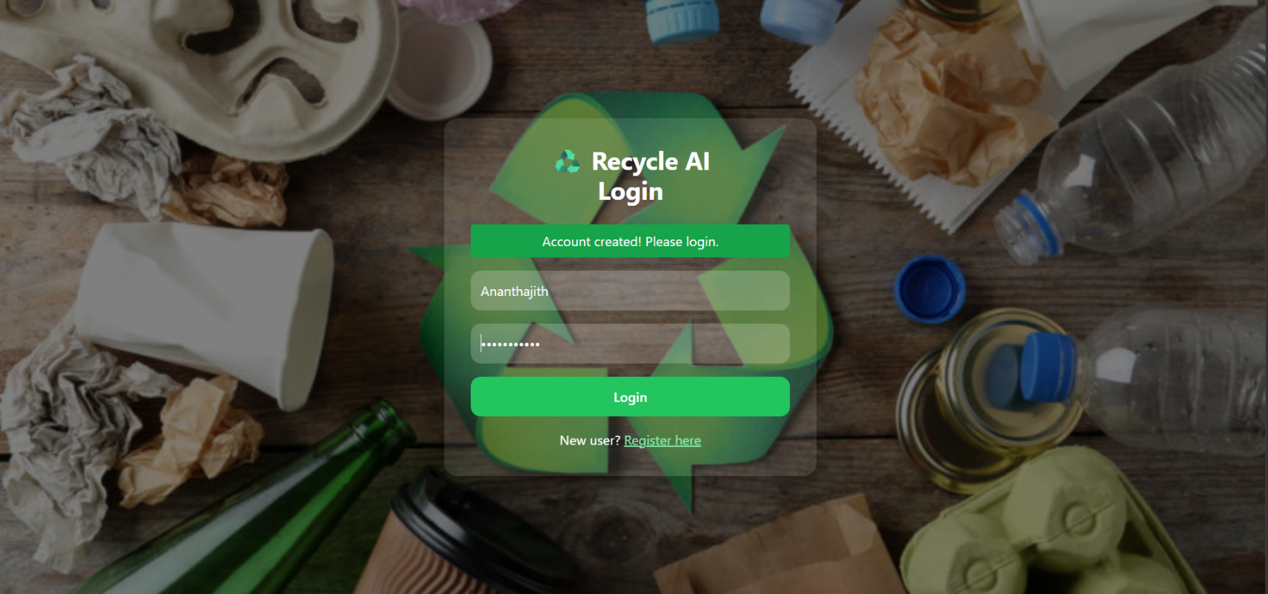
6. Screenshots

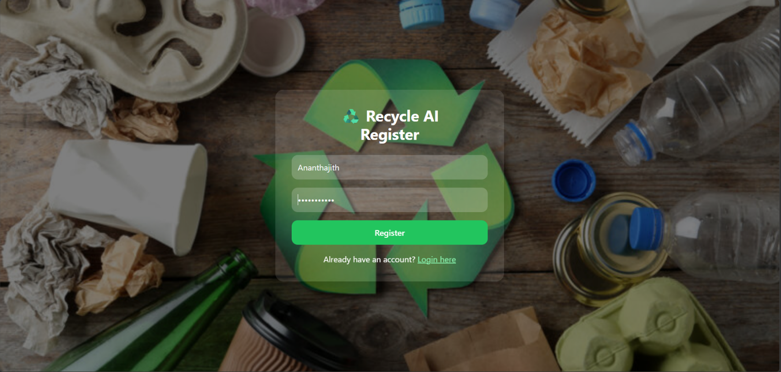
Screenshot 6.1 Login page

Screenshot 6.2 Register page
Department of IT, BRECW Page 25

Identifying Recyclable Items from Image Screenshots

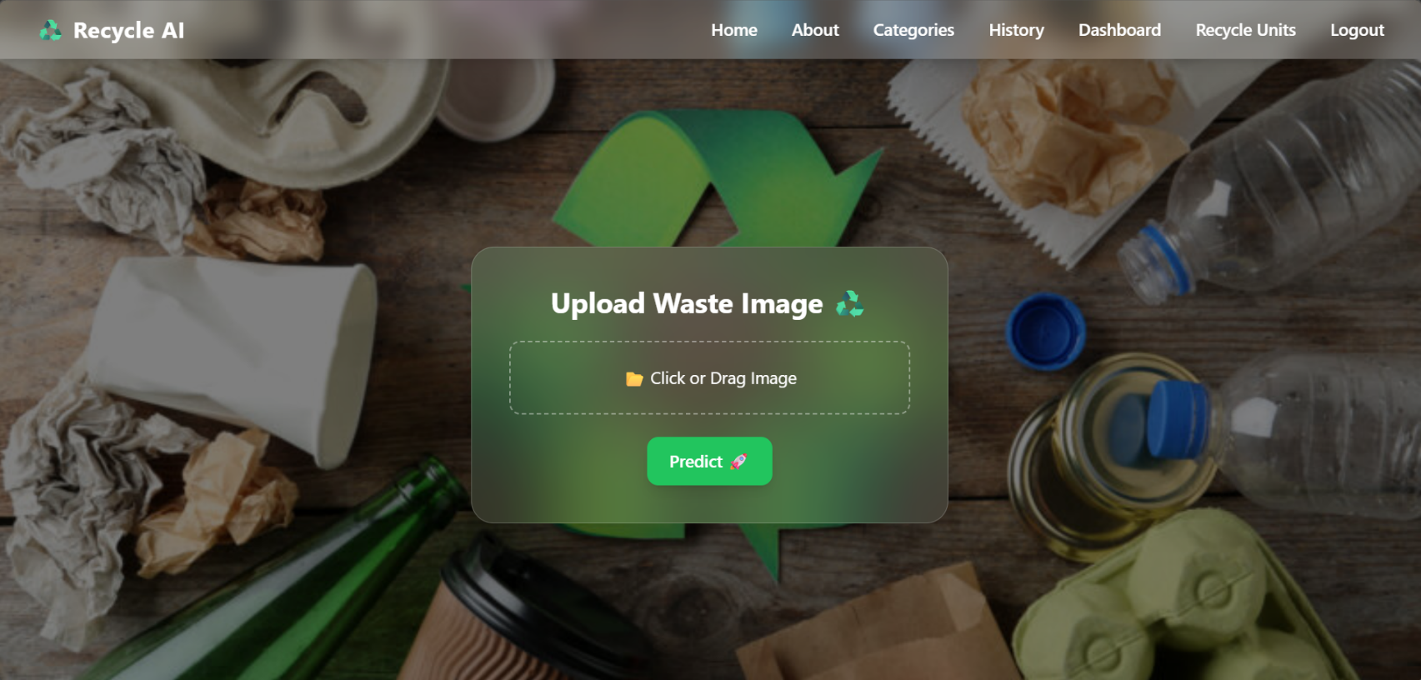
Identifying Recyclable Items from Image Screenshots

Screenshot 6.3 Home page
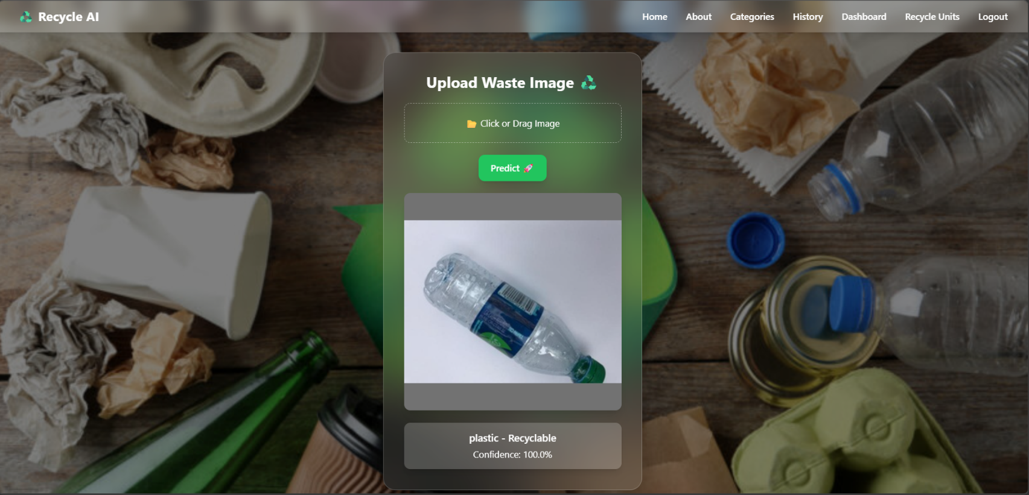

Screenshot 6.4 Result page
Department of IT, BRECW Page 26

Identifying Recyclable Items from Image Screenshots

Identifying Recyclable Items from Image Screen shots

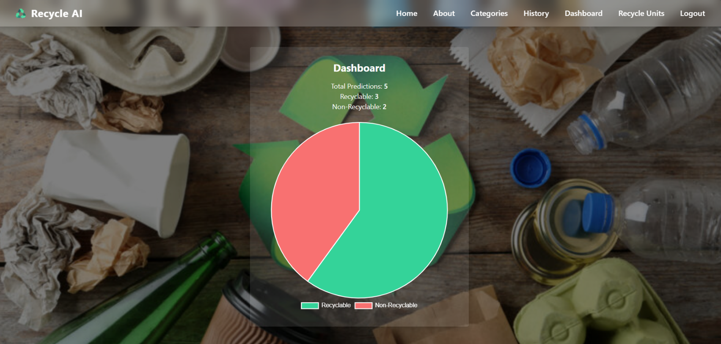

Screenshot 6.5 Dashboard page
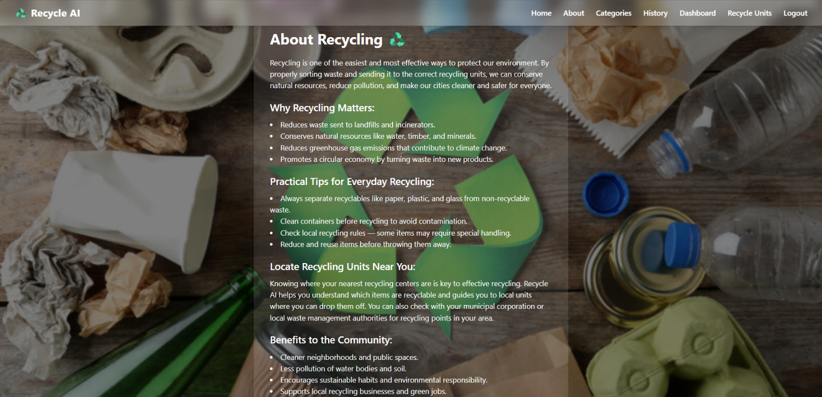
Screenshot 6.6 About page
Department of IT, BRECW Page 27

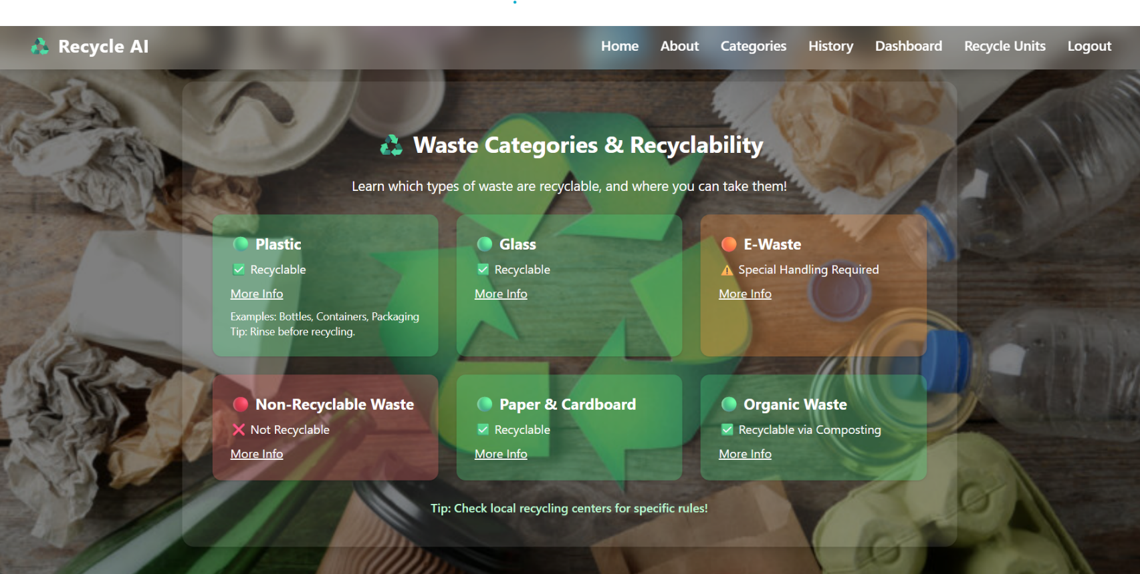
Identifying Recyclable Items from Image Screenshots

Department of IT, BRECW Page 27
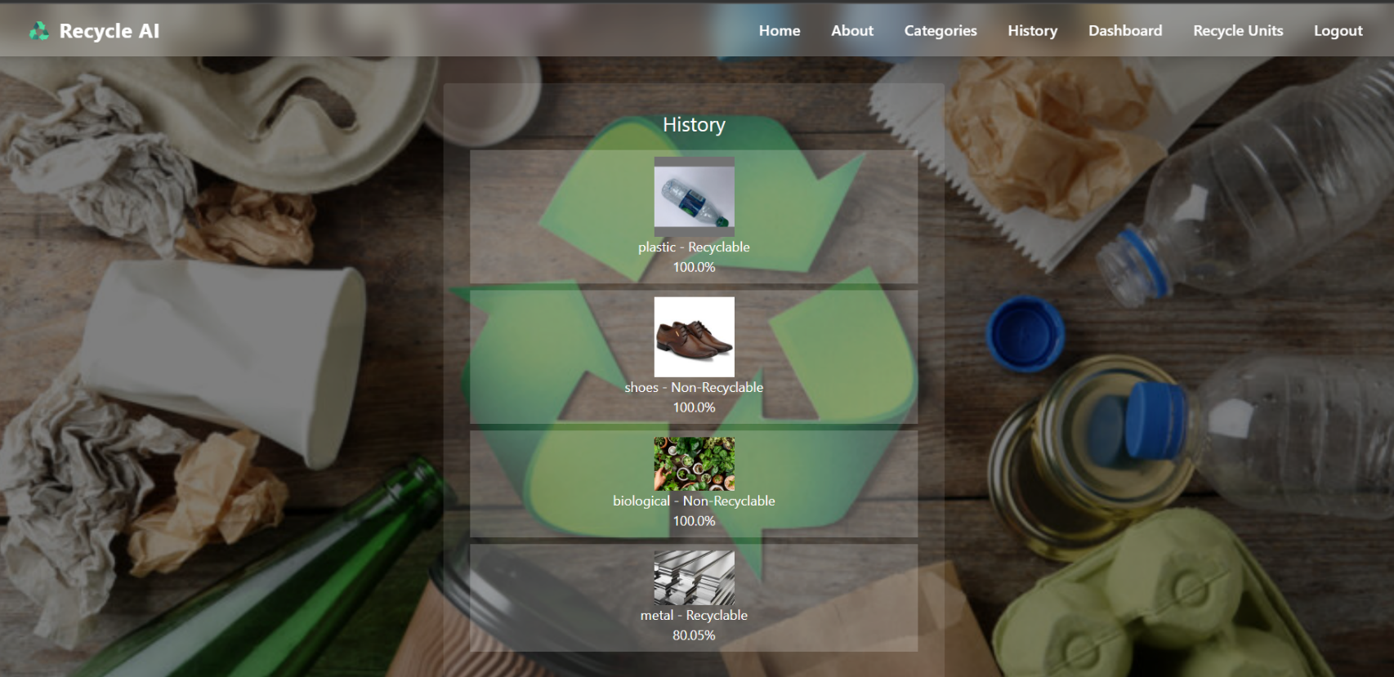
Screenshot 6.7 Categories page

Screenshot 6.8 History page
Department of IT, BRECW Page 28

7. Test Cases
7.Test Cases
Identifying Recyclable Items from Image Test Cases

Test ID | Module | Test Scenario | Input |  | Expected Output |  | Actual output | Status
TC-01 | Image Upload | Upload valid image | JPG/PNG image file |  | Image uploaded successfully |  | Image uploaded successfully | Pass
TC-02 | Image Upload | Upload without image | No file selected |  | Prompt to upload image |  | Prompt to upload image | Pass
TC-03 | Image Upload | Upload invalid file format | PDF/unsupported file |  | Show “Invalid file format” |  | File uploaded (no error)” | Fail
TC-04 | Image Validation | Upload large image | Image > allowed size |  | Show “File size too large” |  | Image accepted | Fail
TC-05 | Preprocessing ooking page | Process valid image | Proper image input |  | Image processed successfully |  | Image processed successfully | Pass
TC-06 | ML Prediction | Predict recyclable item | Image of recyclable item |  | Output: Recyclable |  | Output: Recyclable | Pass
TC-07 | ML Prediction | Wrong classification | Paper image |  | Output: Recyclable |  | Output: Non-Recyclable | Fail
TC-08 | Classification | Detect item category |  | Image (plastic/paper/metal) | Correct category displayed |  | Correct category displayed | Pass
TC-09 | Result Display | Display prediction result | Valid processed image |  | Show result with label & confidence | Show result with label & confidence |  | Pass
TC-10 | System Handling | No image input to model | Empty input |  | Show error “No image provided” | Show error “No image provided” |  | Pass
Department of IT, BRECW Page 29

8. Conclusion
8. Conclusion
Identifying Recyclable Items from Image Conclusion
The project “Identifying Recyclable Items from Images” presents an innovative approach to solving one of the major environmental concerns—waste segregation—by utilizing machine learning and image processing techniques. The system is designed to automatically analyze images of waste items and classify them into recyclable and non-recyclable categories with considerable accuracy.
Through the implementation of image preprocessing, feature extraction, and a trained classification model (such as Convolutional Neural Networks), the project demonstrates how artificial intelligence can simplify and automate complex real-world tasks. The system not only reduces manual effort but also minimizes human error in identifying recyclable materials.
One of the key strengths of this project lies in its user-friendly interface, which allows users to easily upload images and obtain instant results. This makes the system practical and accessible for everyday use, including households, educational institutions, and waste management sectors.
Moreover, the modular architecture of the system ensures flexibility and scalability. Additional features such as real-time object detection, integration with mobile applications, and expansion into multiple waste categories (plastic, metal, organic, e-waste, etc.) can be incorporated in future developments. The inclusion of user feedback mechanisms also opens opportunities for continuous model improvement.
From a broader perspective, this project contributes to promoting environmental awareness and sustainable practices. By enabling users to make informed decisions about waste disposal, it supports cleaner surroundings and efficient recycling processes.
In conclusion, the project successfully bridges the gap between artificial intelligence and environmental sustainability, providing a smart, efficient, and scalable solution for waste classification. It demonstrates the practical impact of technology in solving societal problems and lays a strong foundation for future advancements in intelligent waste management systems.
Department of IT, BRECW Page 30

9.Future Scope

- Future Scope
Identifying Recyclable Items from Image Future Scope

The project can be enhanced by integrating real-time object detection using live camera input for instant classification. The accuracy of the system can be improved by training the model with larger and more diverse datasets covering multiple waste categories such as plastic, metal, and organic waste.
The system can be extended into a mobile application to increase accessibility and usability. It can also be integrated with smart waste management systems like IoT-based smart bins for automated waste segregation.
Additionally, incorporating user feedback and applying advanced techniques like deep learning optimization can further improve system performance.
Department of IT, BRECW Page 31

10. References
10.References
Identifying Recyclable Items from Image References
[1] Ian Goodfellow, Yoshua Bengio, & Aaron Courville (2016). Deep Learning. MIT Press. A fundamental resource for understanding neural networks and deep learning techniques used in image classification.
[2] Adrian Rosebrock (2018). Deep Learning for Computer Vision with Python. PyImageSearch. Provides practical implementation of image processing and object detection techniques.
[3] Richard Szeliski (2010). Computer Vision: Algorithms and Applications. Springer. Covers core concepts of image processing and feature extraction relevant to this project.
[4] Simon Haykin (2009). Neural Networks and Learning Machines. Prentice Hall. A foundational book for understanding machine learning models and training methods.
[5] Mark Nixon & Alberto Aguado (2012). Feature Extraction and Image Processing for Computer Vision. Academic Press. Useful for preprocessing and feature extraction techniques.
[6] TensorFlow, “An end-to-end open-source machine learning platform,” https://www.tensorflow.org
Used for building and training deep learning models.
[7] OpenCV, “Open Source Computer Vision Library,” https://opencv.org
Provides tools for image preprocessing and analysis.
[8] Kaggle, “Datasets for Machine Learning,” https://www.kaggle.com
Used for obtaining datasets for training and testing models.
[9] Scikit-learn, “Machine Learning in Python,” https://scikit-learn.org
Supports model evaluation and preprocessing utilities.
[10] PyTorch, “An open-source machine learning library,” https://pytorch.org
Alternative framework for implementing deep learning models.
[11] NumPy, “Scientific computing with Python,” https://numpy.org
Used for numerical operations in data processing.
[12] Matplotlib, “Python plotting library,” https://matplotlib.org
Used for visualizing results and model performance.
[13] GitHub, “Open-source repositories and ML projects,” https://github.com
Reference for implementation examples and project structure.

Department of IT, BRECW Page 32

